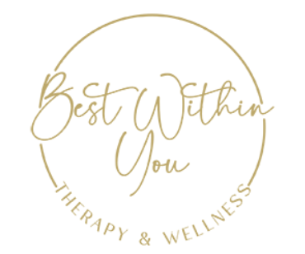

Psychology practice marketing and social media internship

Best Within You Therapy & Wellness is a boutique online psychology practice that specializes in helping clients with eating related concerns and, also, with clients struggling with depression, anxiety, insomnia, and health conditions. We also provide pre-surgery psychological evaluations.

We are looking for someone to help with marketing, social media, and various tasks associated with running a private psychology practice. This is a remote position that you can do from the comfort of your home

We are looking for an intern for our psychology practice to provide support in the following tasks:
1. Blog posts
2. Instagram and FB posts
3. Promoting Best Within You Therapy & Wellness on Facebook groups and engaging in posting on Facebook
4. Helping with marketing materials
5. Tasks related to helping increase our online presence

An ideal candidate would have an interest in mental health. We are looking for someone who has interest and experience with writing blog posts and/or with social media. This could be a good fit for a business, marketing, communications, or psychology major wanting to gain experience in social media and marketing or get experience working for a psychology private practice.

Email drrebeccaleslie@bestwithinyou.com to apply. For more information about the practice, explore: www.bestwithinyou.com

