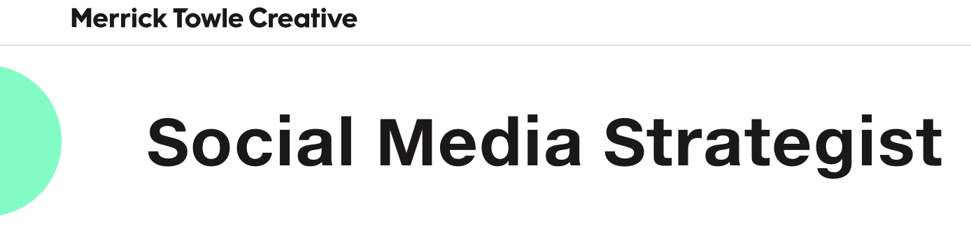

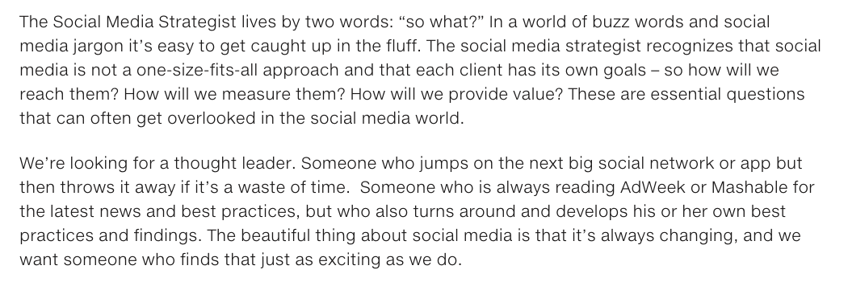

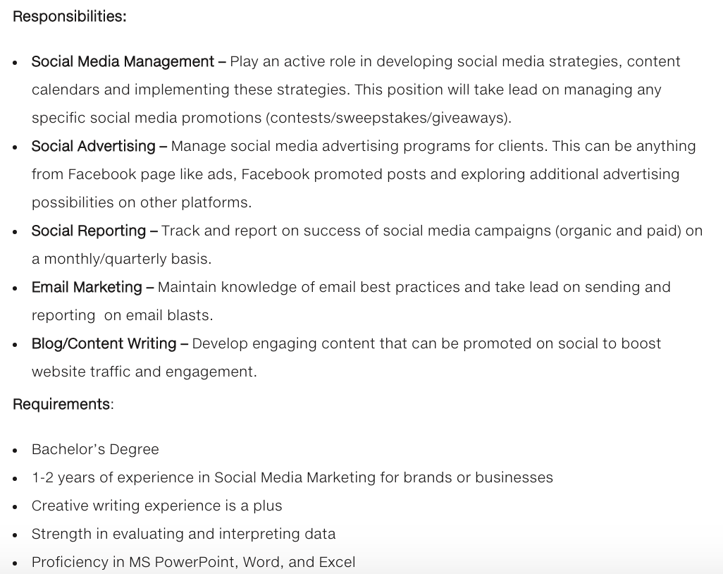

To apply, go to <https://www.merricktowle.com/careers/social-media-strategist/>