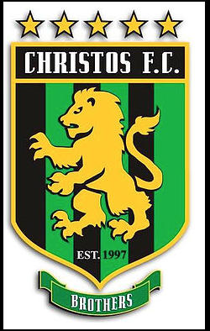
CHRISTOS FC
Advertising and Marketing Internship Opportunity

Christos FC, a 501(c)(3) non-profit adult amateur and youth soccer club operating in Maryland (Annapolis, Northern Anne Arundel County and Charles County), is seeking Interns to assist with advertising and marketing campaigns.

Our internship opportunities are ideally suited for students pursuing a career in advertising and marketing. Our Intern positions offer hands-on experience as Christos begins to execute plans to promote and elevate both its nationally prominent amateur men’s soccer teams and its new youth soccer club.

Established in 1997 as a men’s amateur soccer club, Christos FC has won numerous state and national championships. Christos began to formulate plans last year to create a youth program and is on-target to launch this program in the Fall 2018.

Christos is seeking interns to play an integral role in creating advertising strategies and campaigns to increase public and targeted awareness of the men’s amateur teams and youth club. The majority of the work associated with these placements can be completed remotely – travel to Annapolis on a regular basis will not be required.

Duties and responsibilities
Working closely with the Board of Directors, Head Men’s Coach and Director of Coaching:
- Identify advertising strategies to recruit youth players and to enhance the visibility of the men’s teams
- Create and implement advertising campaigns
- Manage website content
- Manage social media content

Qualifications
Preference will be given to candidates meeting the following criteria:
- Advertising and/or Marketing degree candidate
- Interest in contributing to the development of a start-up organization (youth program)
- Passion for and sincere interest in promoting amateur and youth sports
- Team player whom can work independently
- Willingness to support the Christos FC corporate culture and ethos
- Former youth athlete or current athlete

Selection process will include an interview; two personal references submitted by teachers, professors or employers; non-disclosure agreement; and a criminal background check.

Interested candidates can contact Tony Hall, Director of Coaching: 208.850.5956 or email:
valhalla1959@hotmail.com.

