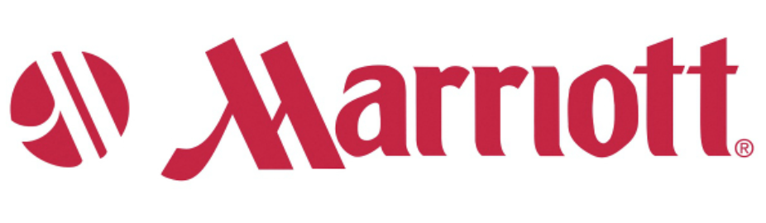
Digital Analyst, Paid Media
Location: Bethesda, Maryland
Category: Administrative

Job Description
Posting Date Apr 20, 2018
Job Number 18000ZS0
Job Category Administrative
Location Marriott International HQ, Bethesda, Maryland
Brand Corporate
Schedule Full-time
Relocation? No
Position Type Management

Start Your Journey With Us
Marriott International is the world’s largest hotel company, with more brands, more hotels and more opportunities for associates to grow and succeed. We believe a great career is a journey of discovery and exploration. So, we ask, where will your journey take you?

JOB SUMMARY
This position is responsible for the execution of paid media and merchandising initiatives for Marriott’s Digital Services group, which creates and supports comprehensive in-house digital services programs for participating hotels. These centralized offerings provide individual hotels with paid media and merchandising services, and functions in an agency like model within the Global eCommerce Digital Services organization.

The Digital Analyst, Paid Media will assist in the execution of digital tactics or services that support the objectives outlined in each hotel’s Digital Business Plan. The position focuses on implementing paid media, merchandising, and email marketing initiatives, as well as optimizing for online travel agencies (OTAs), to acquire new customers for Marriott portfolio hotels. All tactics and services will be economically viable, efficient, repeatable, KPI-driven, and scalable.

The Digital Analyst, Paid Media is tasked with staying up-to-date on industry best-practices and works to implement new ideas, techniques and tactics within the Digital Services programs. He or she will work cross-functionally with Digital Strategists and Senior Analysts supporting all applicable initiatives. This position is responsible for implementation of program deliverables such as bid management, quality review of vendor work, timeliness of tactic delivery and execution and with ad-hoc projects. This position reports to the Manager, Paid Media Management within the Marriott Digital Services Operations team.

CANDIDATE PROFILE
Education and Experience
- BS/BA degree in marketing, advertising, communications, journalism, public relations or related field.
- 1-2 years of relevant work experience required (paid media campaign management and email marketing are preferred).
Agency internship or work experience preferred; tactical execution responsibilities a plus.

To learn more and apply, go to https://jobs.marriott.com/corporate/jobs/18000ZS0?lang=en-US

