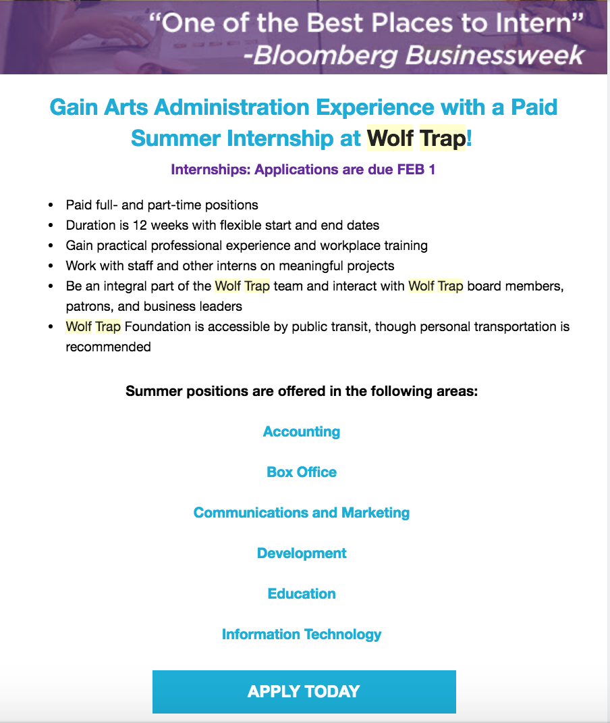

https://www.wolftrap.org/education/internships/summer-internships.aspx?utm_source=MagnetMail&utm_medium=Email&utm_content=19EDU Summer Internship eFlyer RESEND&utm_campaign=Wolftrap Referrals Main

