



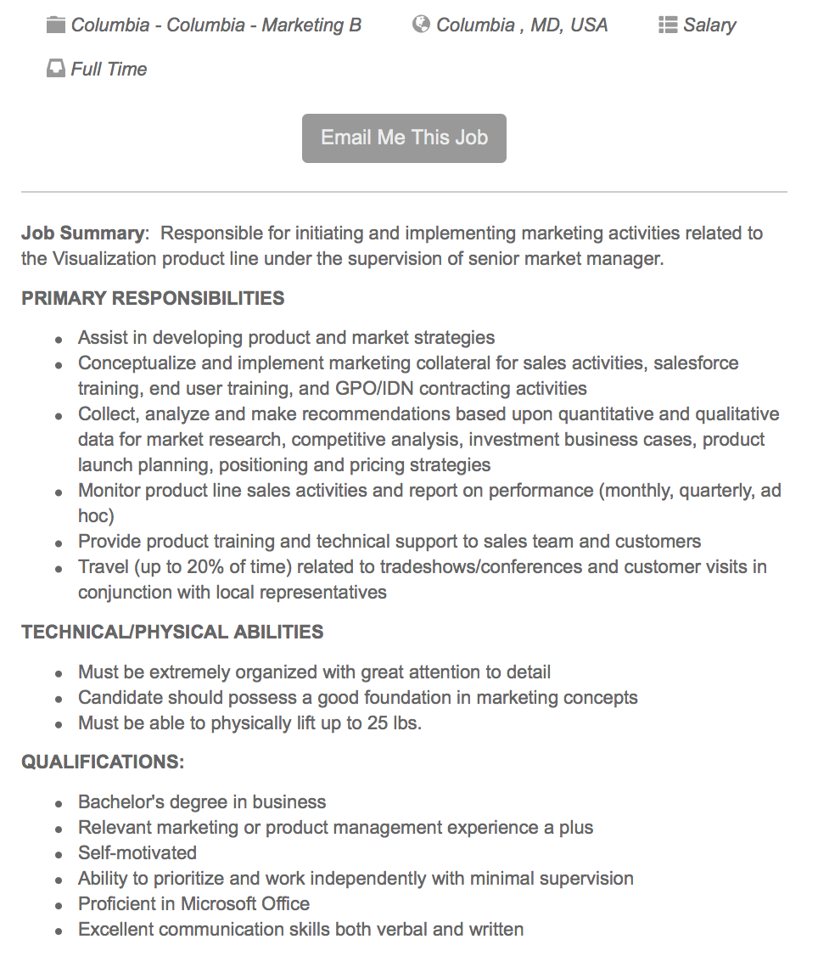

To apply go to:

<https://ambu.hirecentric.com/jobs/125557.html>