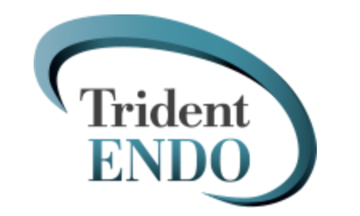

Marketing Coordinator Intern
at Trident Endo
What We're Looking For:
Trident Group is looking for a Marketing Coordinator intern to play a key role in the execution of marketing strategy for multiple partner programs. Reporting to the Director of Business Development, this role will provide tactical marketing support, project management, and daily operations support. This is a great opportunity for someone with a passion for marketing and looking to gain experience in the areas of direct response marketing, marketing strategy, and digital, email and web marketing.

Responsibilities:
- Undertaking daily administrative tasks to ensure the successful management of existing and new referral relationships. Including tracking ROI on multiple initiatives.

- Assisting in the creation of promotional materials. Includes assisting with writing press releases, announcements, brochures, newsletters, etc.

- Support the Marketing Team in organizing various projects such as online campaigns, pay-per-click ads, etc.

- Conducting market research – SWOT analysis

- Assisting with updating website, Google business and social media platforms.

- Updating spreadsheets, databases with statistical, financial and non-financial information.

- Assisting in the organizing of promotional events and attend them to facilitate their success (30 days)

- Preparing promotional presentations/materials

- Updating content on the company’s website and social media accounts

Requirements:
- Must be a junior or senior with experience in managing projects and/or digital marketing

- Understanding of SEO and digital marketing principles.

- Demonstratable ability to multi-task and adhere to deadlines.

- Well-organized with a customer-oriented approach.

- Excellent knowledge of MS Office and online applications (CRM tools, Online analytics, Google Adwords etc.) Prior experience with Hootsuite, placing ads and posts on Instagram, Facebook, LinkedIn and Squarespace is a plus.

- Exquisite communication and people skills. Strong attention to detail with excellent written and verbal communication skills.

Things That Must Be in Your Background:
- 1-2 years of professional work experience, marketing related preferred
Other Attributes That Will Help You in This Role:
- Must be highly organized and have great attention to detail
- Solid verbal, written, and interpersonal communication skills and the ability to work on cross-functional teams
- Using a PC and excel pivot tables
Other info about this position:
$14/hour
Work in the office 4 hours on Monday and Tuesday with Wednesday and Thursday optional for remote
Start in May
About Trident Endo:
Trident Group is the trusted business partner for healthcare practices. Our experts work closely with practice owners to manage and reach their goals. Customizable services include finance, accounting, marketing, recruiting, human resources, operations and practice transitioning.

Why It’s Great to Work at Trident Endo:
Trident Endo offers a high-energy work environment that’s both challenging and fun. We work hard, but our offices are casual and social places. We wear jeans to work and fuel brainstorming sessions with snacks. Option to work remotely half of the time is permitted.

If you are interested, please send your cover letter and resume to Dawn Alexander at dalexander@tridentendo.com.

