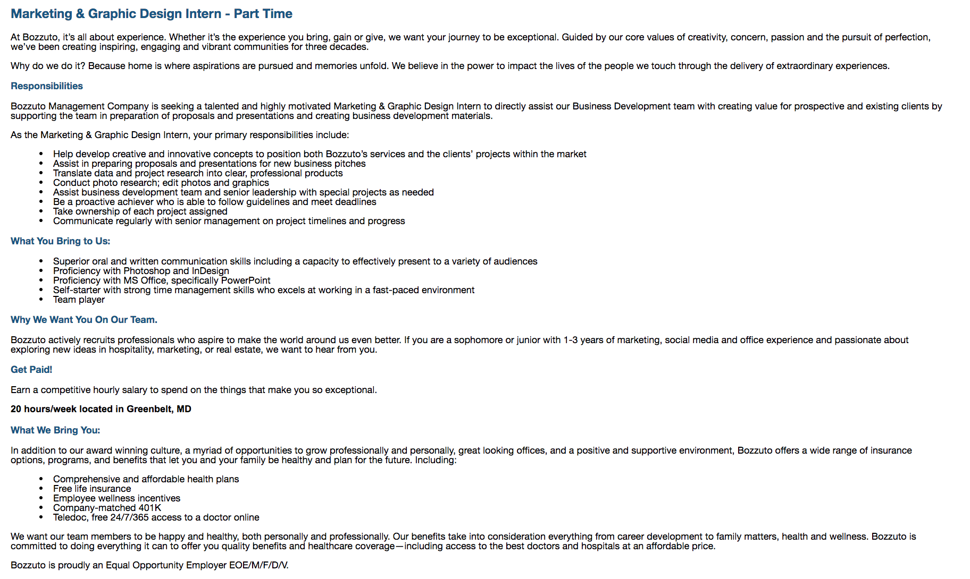

To apply, go to: https://bozzuto.csod.com/ats/careersite/jobdetails.aspx?site=1&c=bozzuto&id=1089