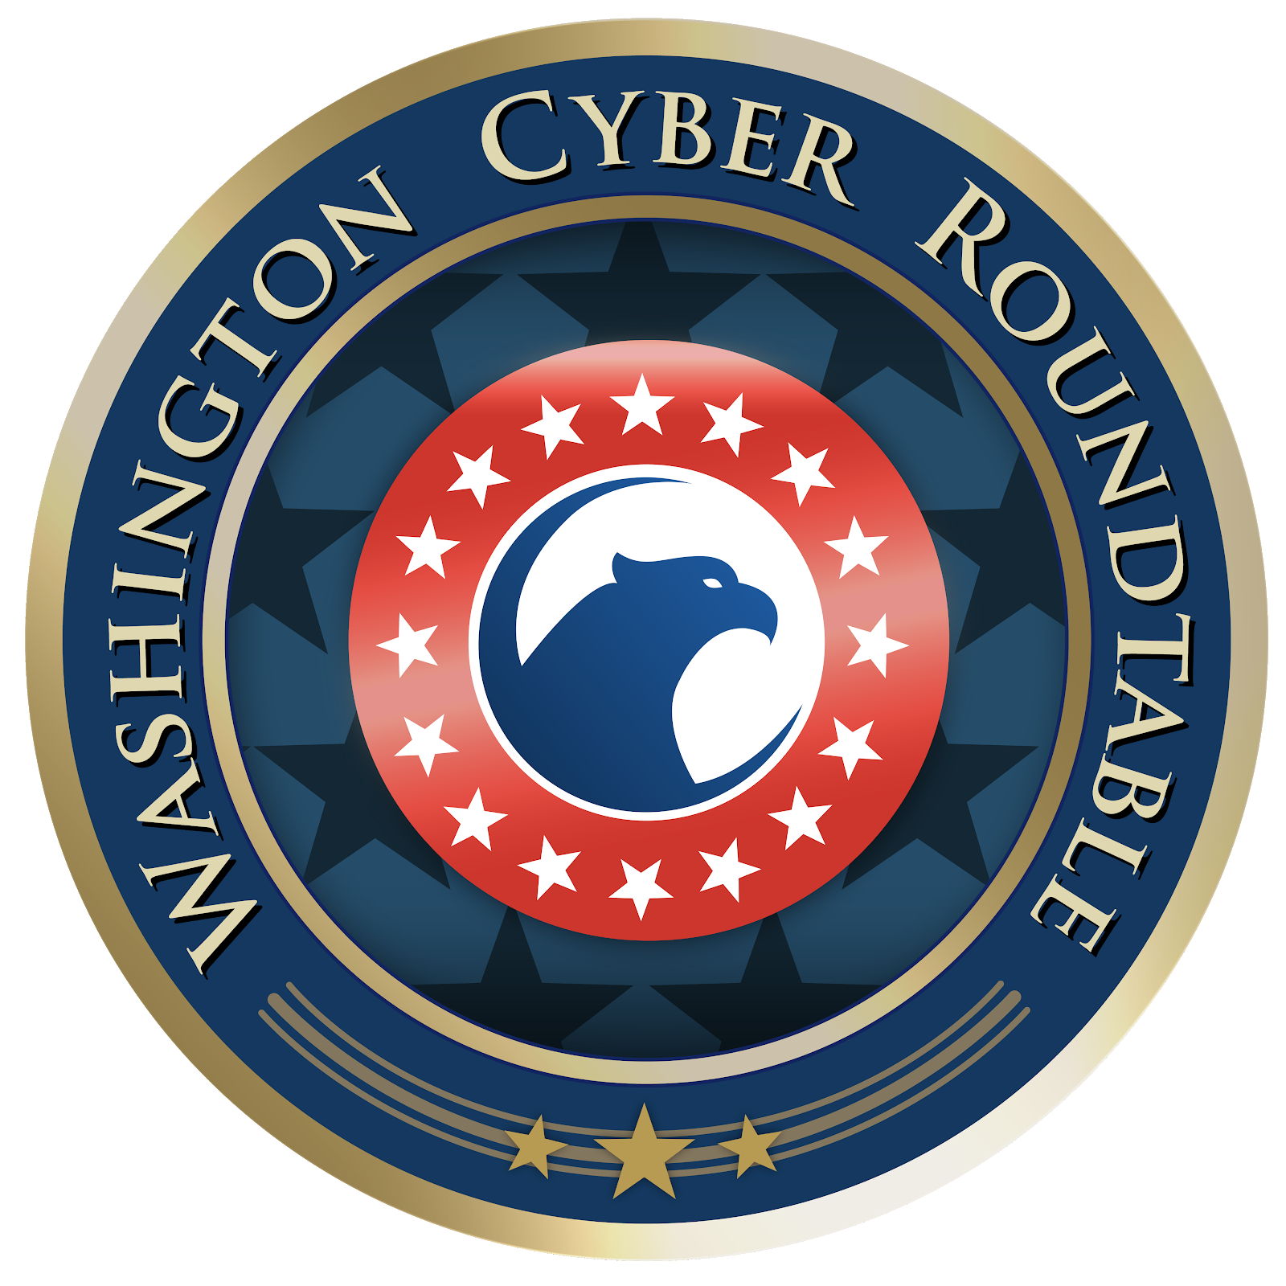
Washington Cyber Roundtable

Job Title: Digital Marketing Internship

Location: Remote

About:
The Washington Cyber Roundtable (WCR) is a non-profit, 501(c)(6) industry liaison group comprising a cross-section of technology, consulting, and professional services firms engaged with and affected by cyber issues. An independent, executive-level organization, WCR provides a venue for identifying research, development, and deployment priorities; disseminating best practices and lessons learned; and enhancing the cybersecurity posture of the public sector.

www.washingtoncyber.org

General Job Description:
Digital marketing intern will work directly with the WCR leadership team to create a strategic digital marketing campaign. The marketing intern will oversee execution of the plan and proactively engage a digital audience through social media accounts and electronic outreach. This is an excellent opportunity for a candidate interested in gaining experience on end-to-end components of digital marketing and exposure to senior members of the defense contracting community.

Because WCR is run by volunteers this is an unpaid internship.

Major Duties and Responsibilities:
- Create content and manage upkeep of the social media accounts
- Schedule posts to push out daily to Twitter
- Weekly posts to LinkedIn page and WCR restricted group page
- Post to social media accounts to promote events while maintaining the non-attribution aspect of events while providing context on topics for release to the public
- Work with members of the WCR staff in engaging current and potential speakers and members

Time Requirements
- About 3-6 hours of planning, content creation and coordination a week through efforts including but not limited to:
  - Biweekly staff calls (30 mins)
  - Weekly check-ins with Managing Director (via email or phone)
  - 14 planned Twitter posts a week and at least 2 retweets a day
  - 1 planned LinkedIn announcement a week
  - 1 LinkedIn Conversation a week
  - Option to attend monthly roundtable events featuring c-suite executives from government and industry in Tysons Corner

Minimum Qualifications:
Pursuing bachelor’s degree in one of the following disciplines, business, marketing, journalism, literature, computer science or government & politics with an interest in technology and government. The candidate should possess the ability to coordinate with a team remotely. Candidate understands that he/she will be responsible for customer outreach through social media. Knowledgeable in LinkedIn, Twitter, Google Docs, Google Drive, Google Plus, Instagram, Wix.

Preferable:
Background in marketing, business. Ideally they will have an interest in cybersecurity, social media savvy, creative, energetic, writing. Some advertising experience though not required.
Live in the D.C. metro area
Able to commit at least a year

Any interested candidates should reach out to: bulavinetz@washingtoncyber.org

